Location Recommendation Engine for Opening a Restaurant

By

Mohammed Tausif Khan

(P.S. - Assumption of location for demonstration of this project is Mumbai)

## Problem Statement

* The city of Mumbai has a large amount restaurants, but still there is always scope for new ones. To have open and run a new restaurant and make it into successful business needs hard work.
* There are many factors that are in play for a restaurant to succeed or fail such as the price of the food, quality of the food, Customer service, ambiance, etc.
* Another major factor is the competition nearby competition. If there is a competition it will always have an impact on the business, no matter how good the business is.
* Finding a suitable location for it to flourish is the most important factor for a restaurant. It has to be set up in a location where one can attract a good crowd as well as it must be located in an area where there is little or no competition.
* We will be able to provide a solution for anyone looking to open a Chinese cuisine restaurant (or any other cuisine for a matter of fact) in the city of Mumbai.
* The Goal of this problem is to find a location that suits the below criteria.
  + A location that has many restaurants in the vicinity (European, Intercontinental, Indian)
  + A location that has no or few Chinese cuisine restaurants, as this will ensure that there very little competition with other competitors.

## Data Description

* The data that will be used in this projects is a csv file having data related to all neighborhoods in the city of Mumbai which has been created manually for this project.

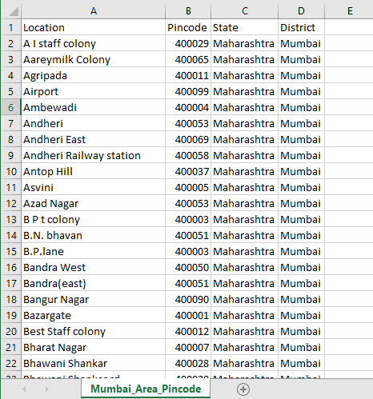

* Finding a suitable location for a restaurant to flourish is an important
* We will explore the neighborhoods using Foursquare API to find the venues within 500 meters of each neighborhood.
* The Foursquare API that will be used to explore the neighborhoods is <https://api.foursquare.com/v2/venues/explore>.
* This API returns json response which will be transformed into a Data Frame, taking only the required details into consideration.